**Scanner Parser**

Contents

What is KAY? 1

Lexical syntax 1

EBNF syntax 1

Abstract syntax 1

Scanner files 1

Parser files 2

# What is KAY?

Kay is similar to JAY. I changed the syntax a little bit. Check the grammars. I highlighted the changes.

# Lexical syntax

Rules 8, 10 and 13 are changed with respect to JAY.

* void is not a keyword in KAY.
* := is an operator in KAY.
* True and False are uppercased in KAY.
* bool and integer are keywords in KAY.

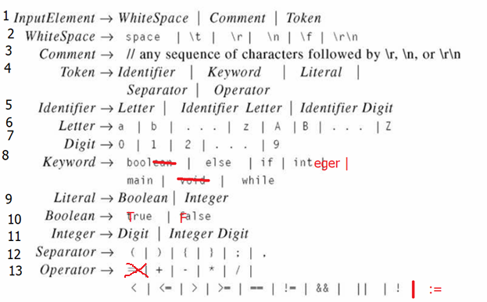

# EBNF concrete syntax

Rules 1, 4 and 9 changed with respect to JAY.

* A program is of the form main{ …. }
* The types are integer and bool.
* Assignment is built on :=. For example, x := 5.

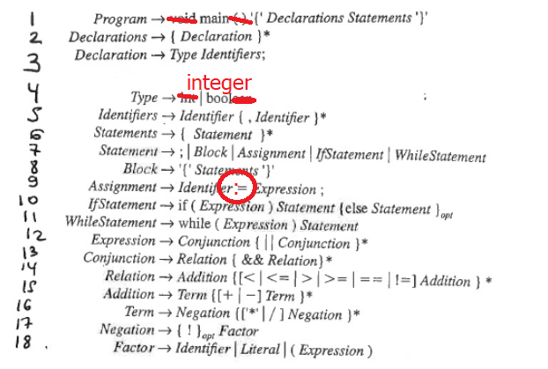

# Abstract syntax

KAY has the same abstract syntax as JAY.

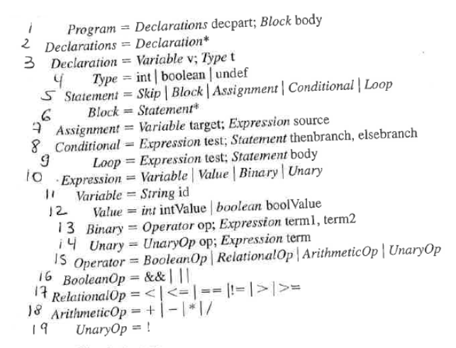

# **Scanner files**

**Token.java -** Description of a Token – type and value

**TokenStream.java -** TO COMPLETE to implement the lexical analysis of Jay

**ScannerDemo.java -** TO COMPLETE to print the list of token this **EXACT** way:

Token 1 - Type: Literal - Value: 31  
Token 2 - Type: Other - Value: 3a

**Start by completing ScannerDemo.java**

**prog1.jay -** initial test for the scanner (provided test)

**Post in Discord the expected outputs of prog1.jay**

**You can checkout** <https://bit.ly/kaysannertest> **for potential tests for KAY.**

Your scanner will be tested against the provided test and a set of hidden test (like in HackerRank). You will get -10 points for each test. Note: There are more than 10 tests but you will not get a negative grade!

**Your code will be available on GitHub and needs to show work (commits) from both students.**

# **Parser files**

**Program.java – Implements the a**bstract syntax. Nothing to change

**ConcreteSyntax.java -** TO COMPLETE to implement the syntactical analysis of Jay

**ParserDemo.java -** TO COMPLETE to print the parse tree this **EXACT** way:

For the KAY program:

main{

  integer i;

  i := 7;

}

The output is:

Abstract syntax of the KAY Program:   
  Declarations:   
    Declarations = {<i, integer>}  
  Block:   
    Assignment:   
      Variable: i  
      Value: 7

In case there is an error message, the output is **something like** this:

Syntax error - Expecting: main But saw: Identifier: void  
Exception in thread "main" java.lang.RuntimeException: Syntax error - Expecting: main But saw: Identifier = void  
    at ConcreteSyntax.match(ConcreteSyntax.java:43)  
    at ConcreteSyntax.program(ConcreteSyntax.java:54)  
    at ParserDemo.main(ParserDemo.java:9)

Your parser will be tested against the provided tests and a set of hidden tests (like in HackerRank). You will get -10 points for each test. Note: There are more than 10 tests but you will not get a negative grade!

**Your code will be available on GitHub and needs to show work (commits) from both students.**